Supplemental Informations

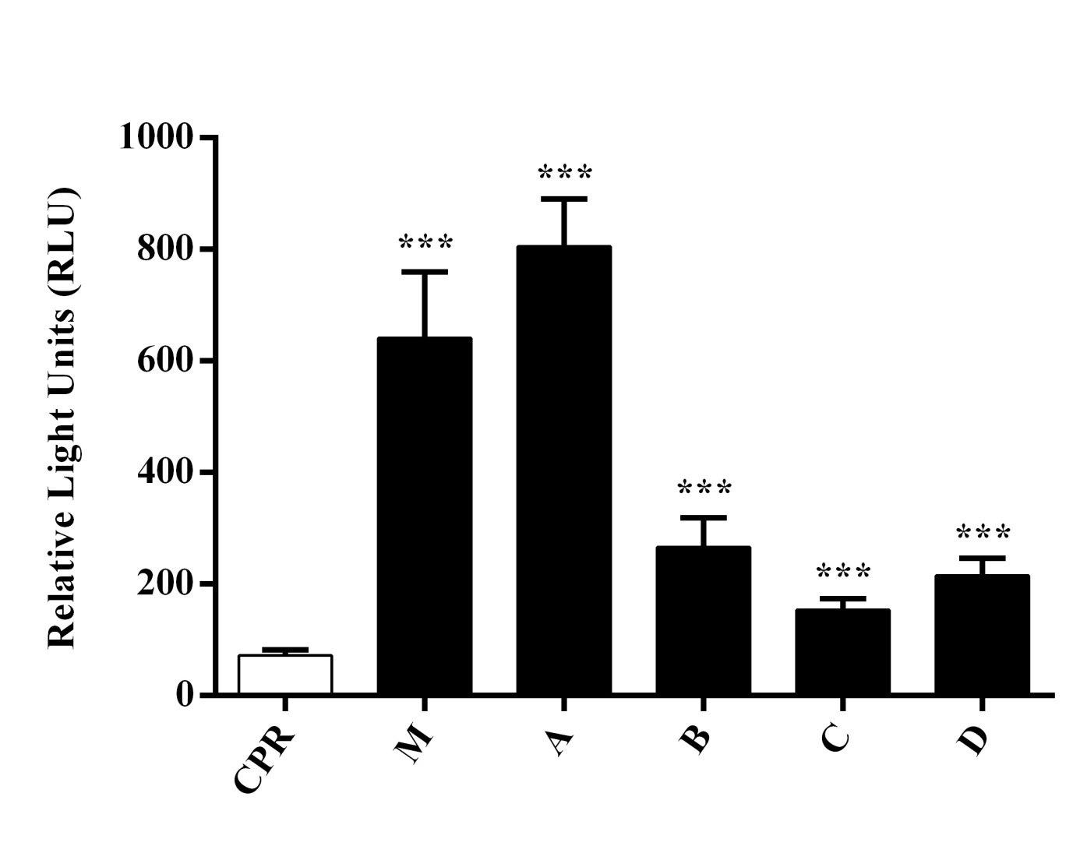

**Fig. S1.** Enzymatic activity of enzyme bag cocktail M (containing all 57 CYPs) and cocktails A-D (each containing 14 or 15 CYPs) towards the substrate Luciferin 6' 2-fluorobenzyl ether methyl ester (**Luciferin-2FBEME**). CPR: Control with enzyme bags containing only the microsomal electron transfer protein (cytochrome P450 reductase, CPR). \*\*\**P* < 0.005.

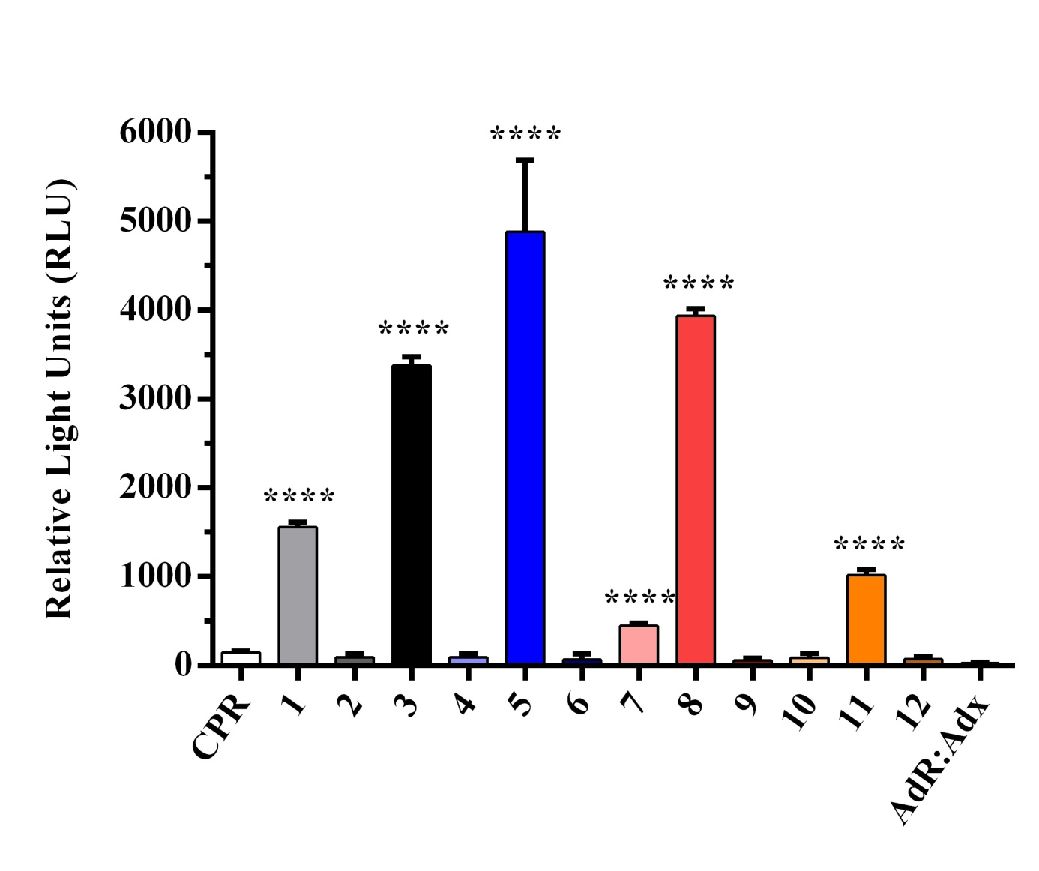

**Fig. S2.** Enzymatic activity of enzyme bag cocktails 1-12 (each containing 4 or 5 CYPs) towards the substrate Luciferin 6' 2-fluorobenzyl ether methyl ester (**Luciferin-2FBEME**). CPR: Control with enzyme bags containing only the microsomal electron transfer protein. Adx-AdR: Control with enzyme bags containing only the mitochondrial electron transport proteins adrenodoxin and adrenodoxin reductase. \*\*\*\**P* < 0.001.

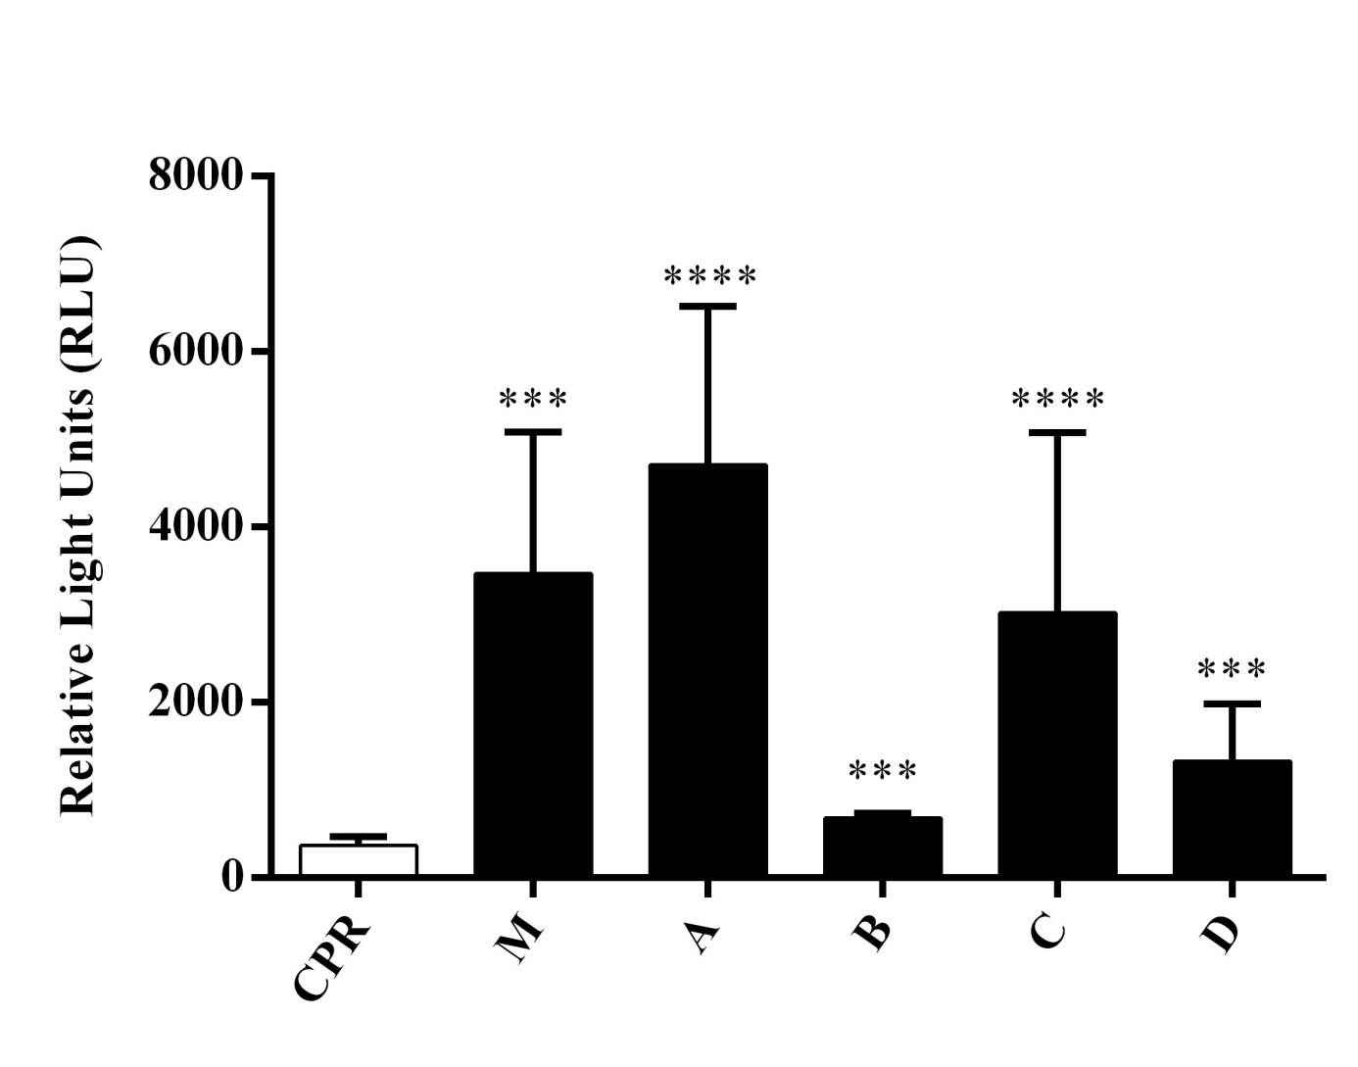

**Fig. S3.** Enzymatic activity of enzyme bag cocktail M (containing all 57 CYPs) and cocktails A-D (each containing 14 or 15 CYPs) towards the substrate Luciferin 6' 3-fluorobenzyl ether methyl ester (**Luciferin-3FBEME**). CPR: Control with enzyme bags containing only the microsomal electron transfer protein. \*\*\**P* < 0.005; \*\*\*\**P* < 0.001.

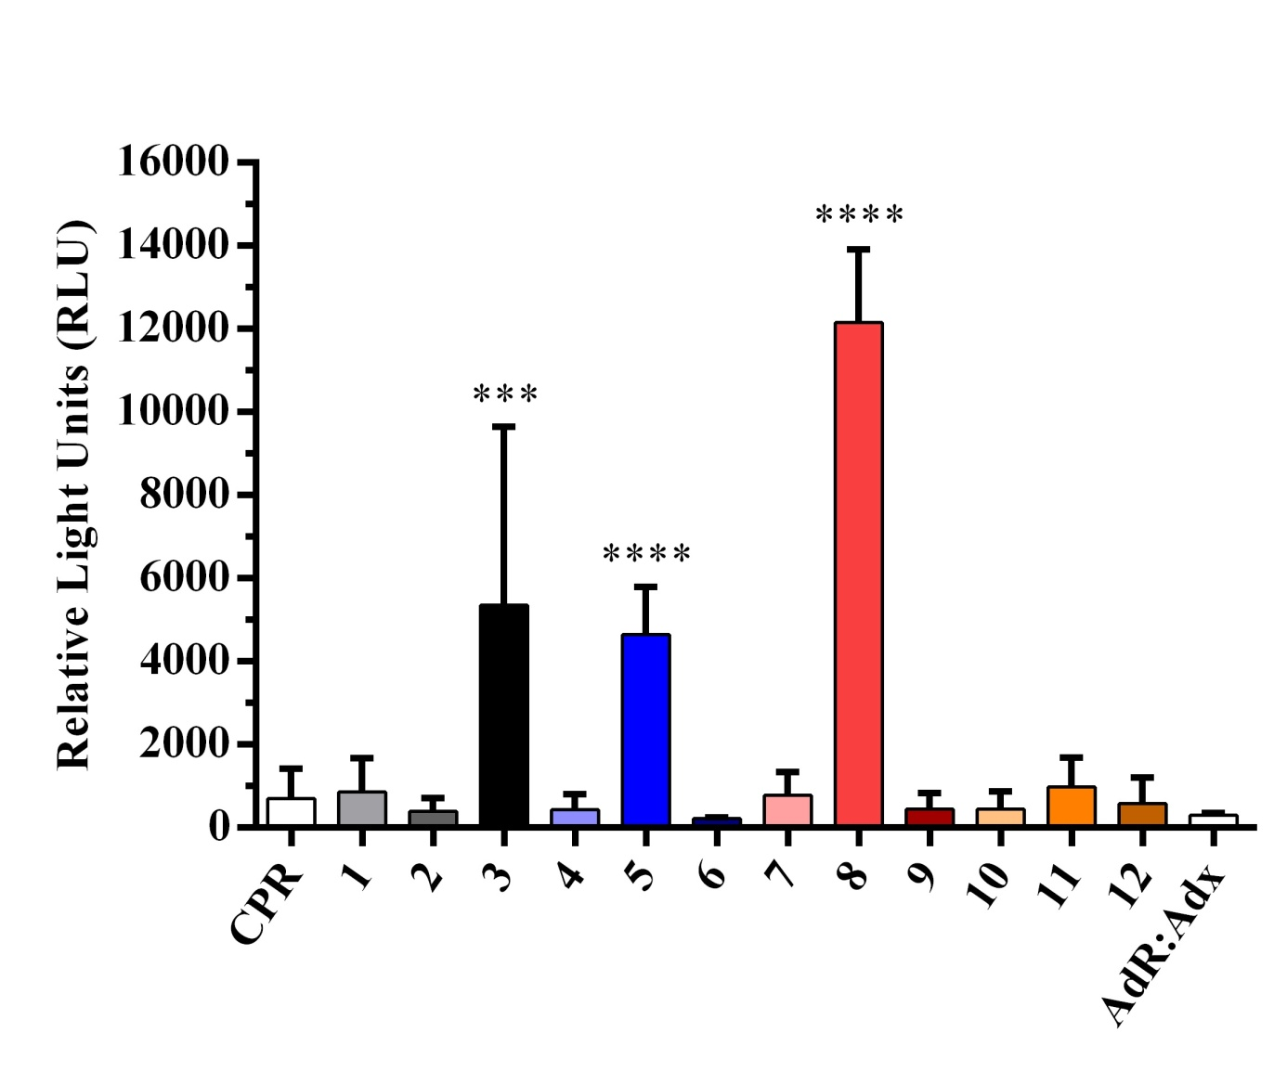

**Fig. S4.** Enzymatic activity of enzyme bag cocktails 1-12 (each containing 4 or 5 CYPs) towards the substrate Luciferin 6' 3-fluorobenzyl ether methyl ester (**Luciferin-3FBEME**). CPR: Control with enzyme bags containing only the microsomal electron transfer protein. Adx-AdR: Control with enzyme bags containing only the mitochondrial electron transport proteins. \*\*\**P* < 0.005; \*\*\*\**P* < 0.001.

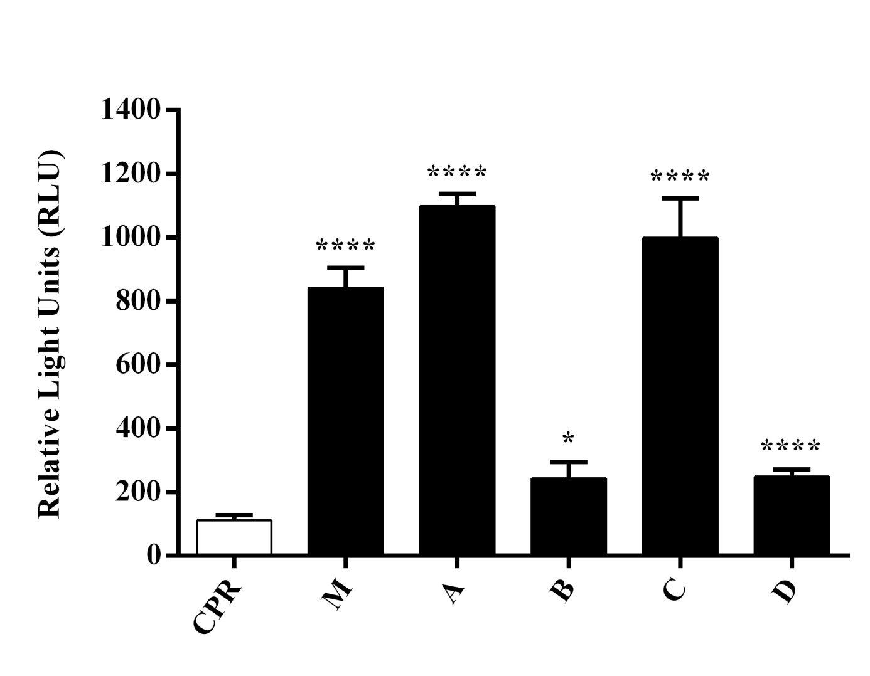

**Fig. S5.** Enzymatic activity of enzyme bag cocktail M (containing all 57 CYPs) and cocktails A-D (each containing 14 or 15 CYPs) towards the substrate Luciferin 6' 4-fluorobenzyl ether methyl ester (**Luciferin-4FBEME**). CPR: Control with enzyme bags containing only the microsomal electron transfer protein. \**P* < 0.05; \*\*\*\**P* < 0.001.

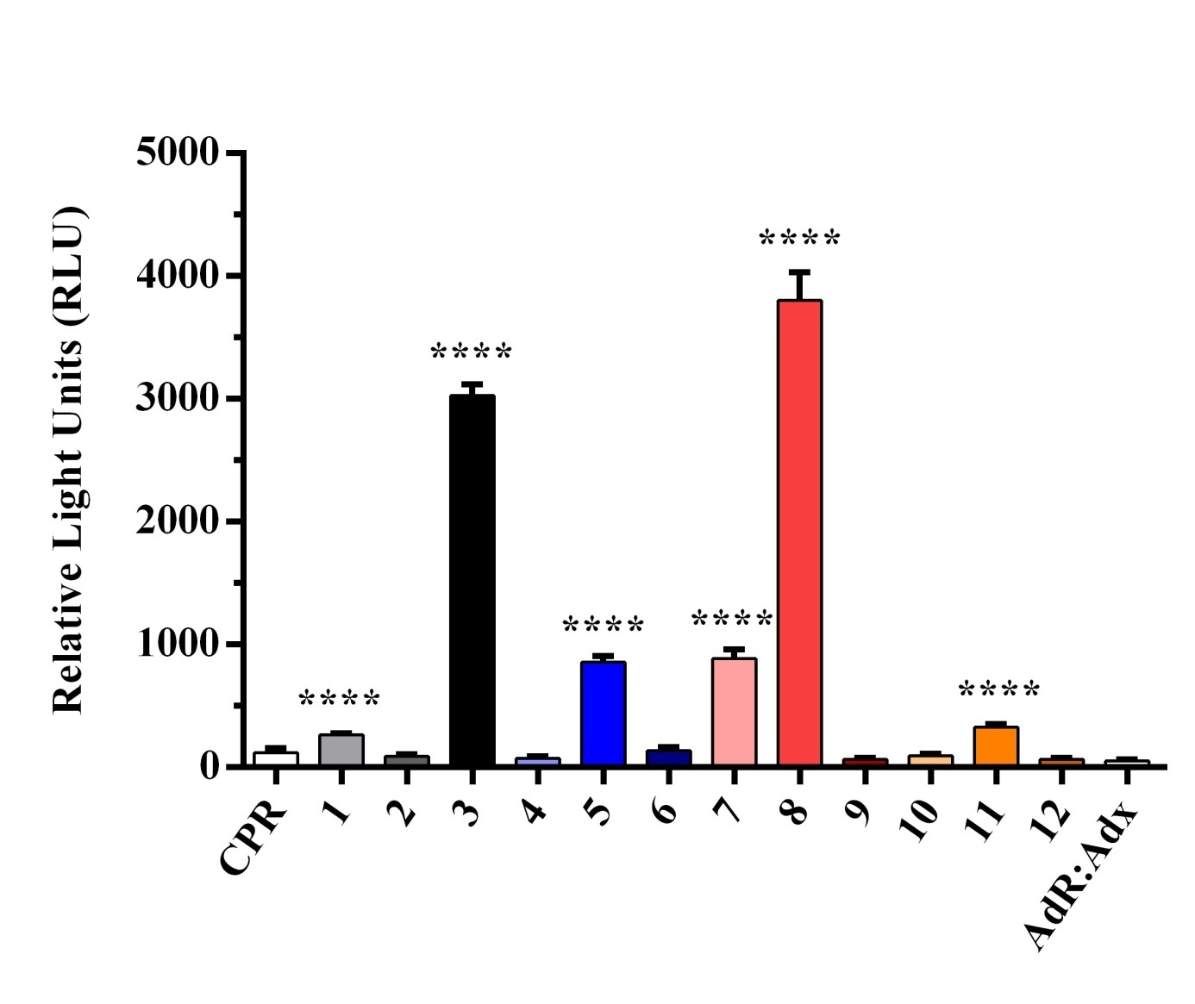

**Fig. S6.** Enzymatic activity of enzyme bag cocktails 1-12 (each containing 4 or 5 CYPs) towards the substrate Luciferin 6' 4-fluorobenzyl ether methyl ester (**Luciferin-4FBEME**). CPR: Control with enzyme bags containing only the microsomal electron transfer protein. Adx-AdR: Control with enzyme bags containing only the mitochondrial electron transport proteins. \*\*\*\**P* < 0.001.

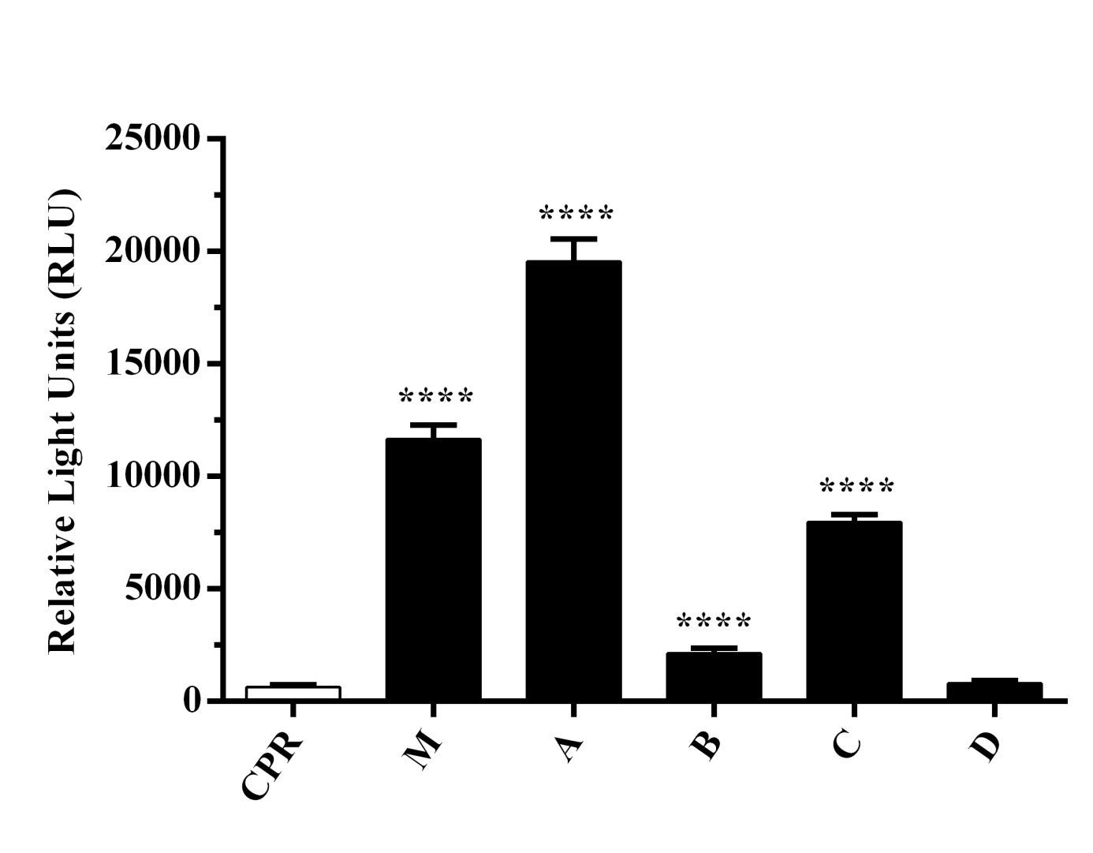

**Fig. S7.** Enzymatic activity of enzyme bag cocktail M (containing all 57 CYPs) and cocktails A-D (each containing 14 or 15 CYPs) towards the substrate Luciferin 6' 3-furfuryl ether methyl ester (**Luciferin-3FEME**). CPR: Control with enzyme bags containing only the microsomal electron transfer protein. \*\*\*\**P* < 0.001.

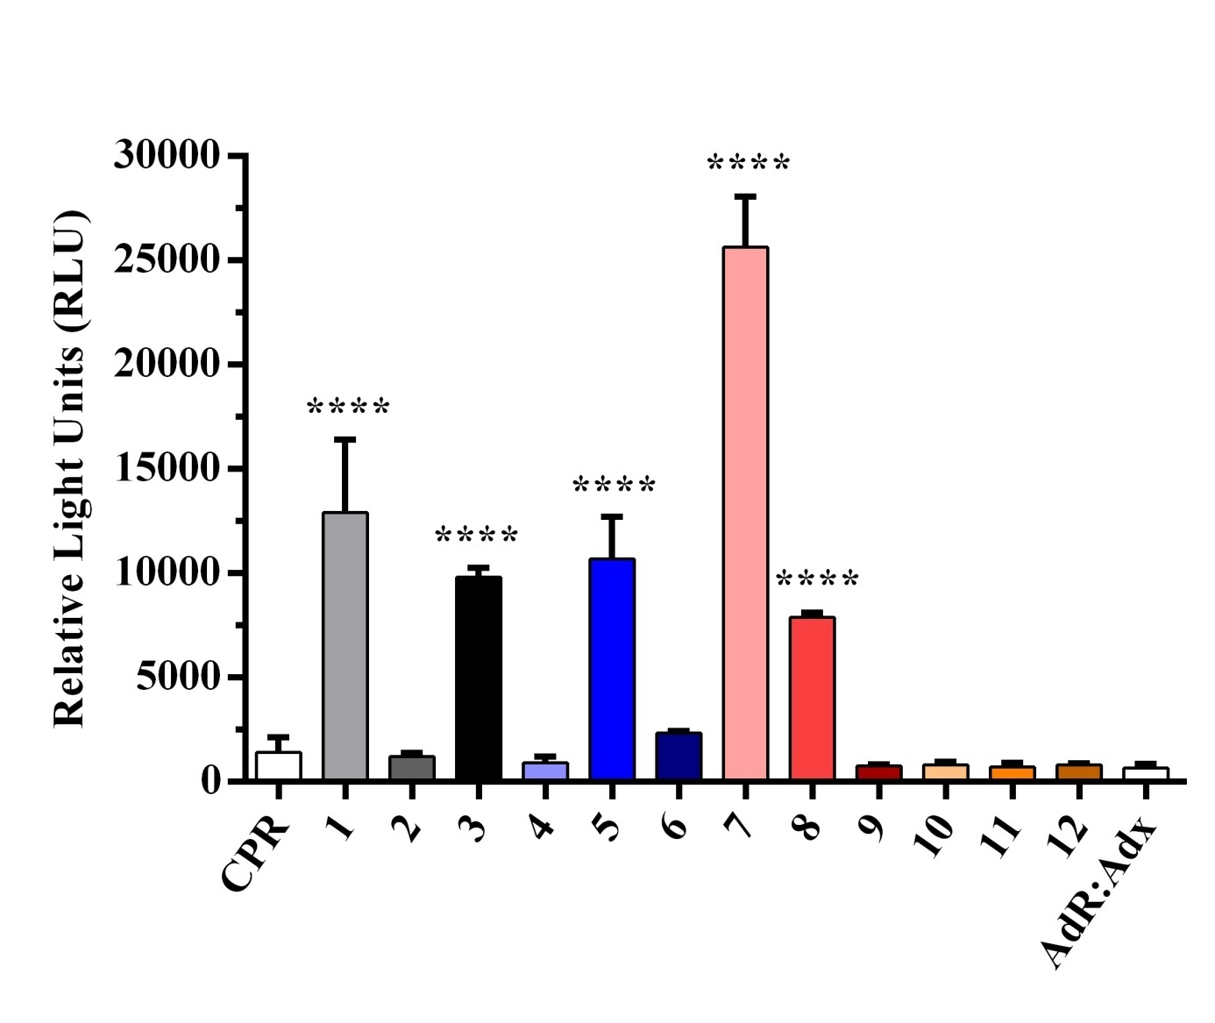

**Fig. S8.** Enzymatic activity of enzyme bag cocktails 1-12 (each containing 4 or 5 CYPs) towards the substrate Luciferin 6' 3-furfuryl ether methyl ester (**Luciferin-3FEME**). CPR: Control with enzyme bags containing only the microsomal electron transfer protein. Adx-AdR: Control with enzyme bags containing only the mitochondrial electron transport proteins. \*\*\*\**P* < 0.001.

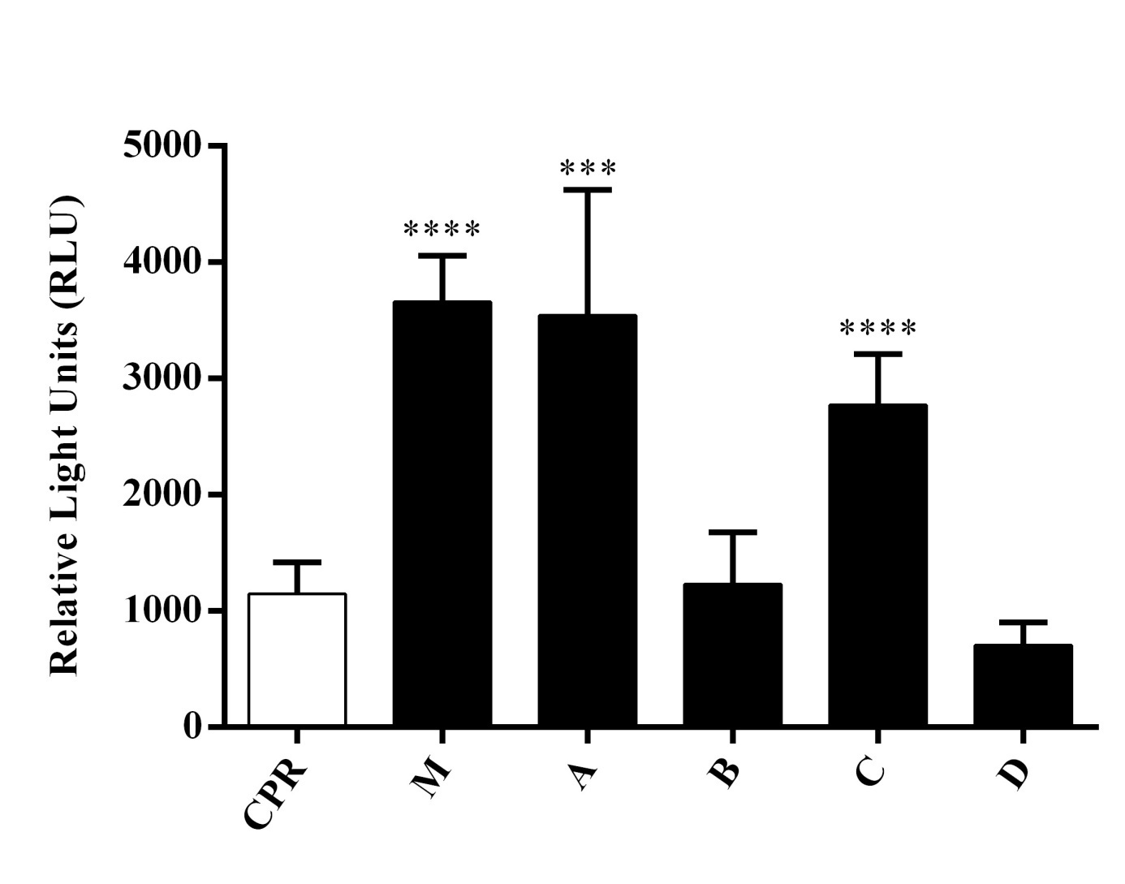

**Fig. S9.** Enzymatic activity of enzyme bag cocktail M (containing all 57 CYPs) and cocktails A-D (each containing 14 or 15 CYPs) towards the substrate Luciferin 6' 3-thenyl ether methyl ester (**Luciferin-3TEME**). CPR: Control with enzyme bags containing only the microsomal electron transfer protein. \*\*\**P* < 0.005; \*\*\*\**P* < 0.001.

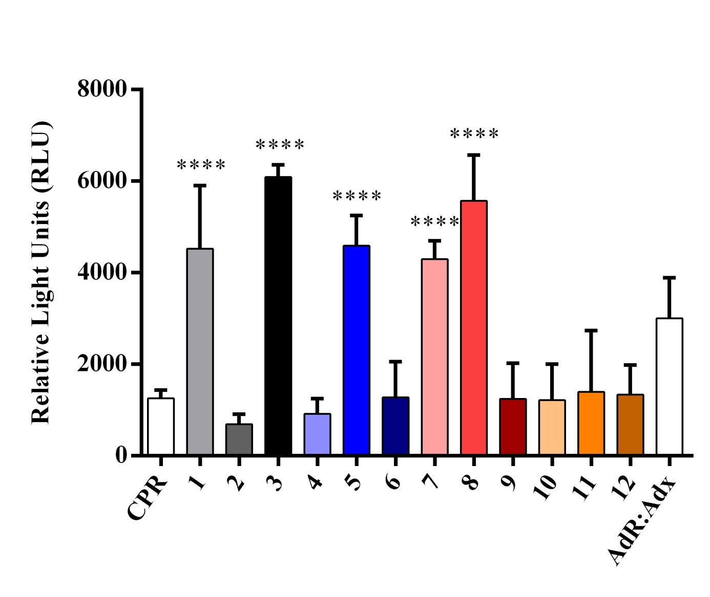

**Fig. S10.** Enzymatic activity of enzyme bag cocktails 1-12 (each containing 4 or 5 CYPs) towards the substrate Luciferin 6' 3-thenyl ether methyl ester (**Luciferin-3TEME**). CPR: Control with enzyme bags containing only the microsomal electron transfer protein. Adx-AdR: Control with enzyme bags containing only the mitochondrial electron transport proteins. \*\*\*\**P* < 0.001.

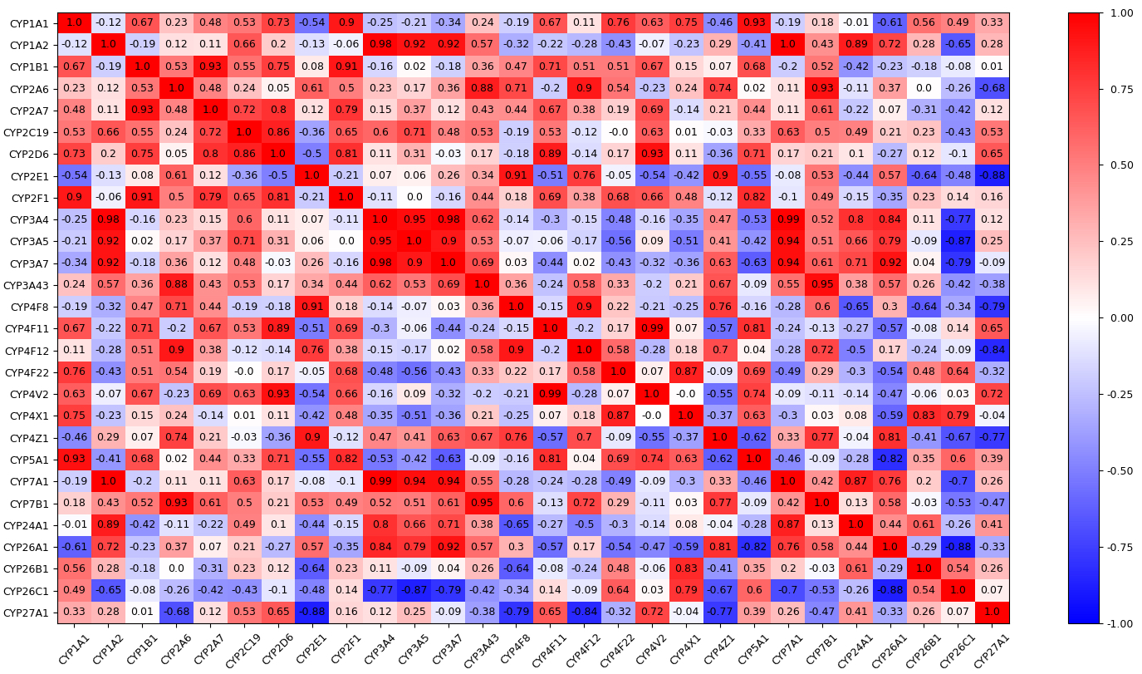

**Fig. S11.** Correlation matrix for enzyme activity with respect to the five substrates used in this study. The correlations quantify the similar or dissimilar nature of the behavior of two given enzymes with respect to all five substrates, with a value close to 1 (red) corresponding to similar behavior, -1 (blue) to opposite behavior and 0 (white) to uncorrelated behavior. By construction correlation matrices are diagonally symmetric, meaning that all information is contained in the upper right triangle. This method of analysis permits to quantify the similarities of enzyme activities in such a way as to allow for grouping of enzymes that show pairwise similar behavior, something that can only be done on a qualitative level by visually comparing their individual radar plots.

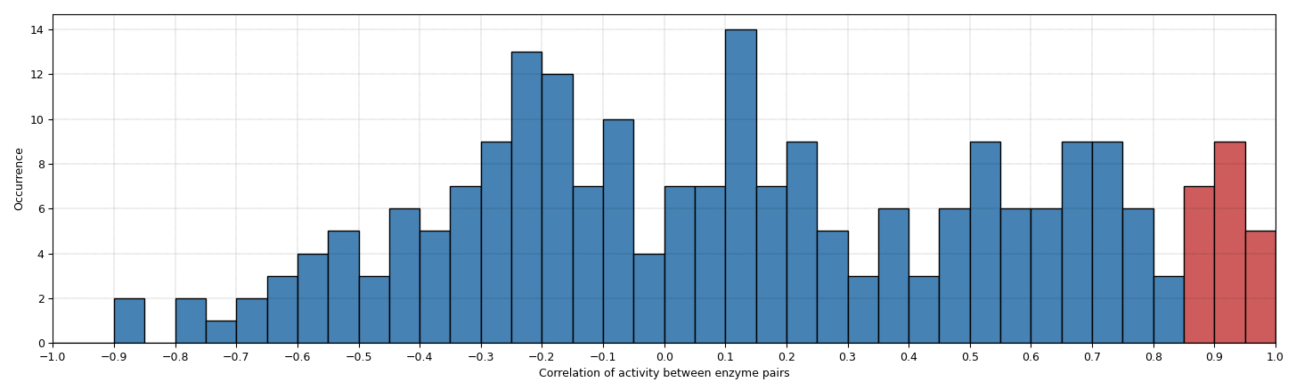

**Fig. S12.** Histogram of the correlation data extracted from the correlation matrix (Fig. S11). The distribution of occurrences at the high end of the spectrum (red) suggests a possible grouping criterion for enzymes with similar activity of having pairwise correlations of at least 0.85.